**WAREHOUSE & DISTRIBUTION CENTER MIRRORS**

Convex and dome mirrors are your most immediate visual warnings, when approaching a blind intersection. Pedestrians and forklift operators benefit from having properly placed mirrors to provide a view of persons or objects blocked by common blind spots.

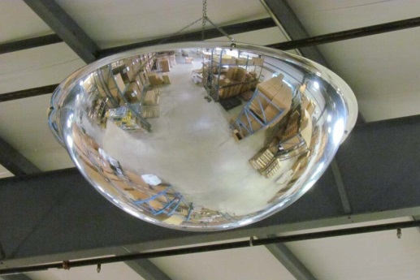 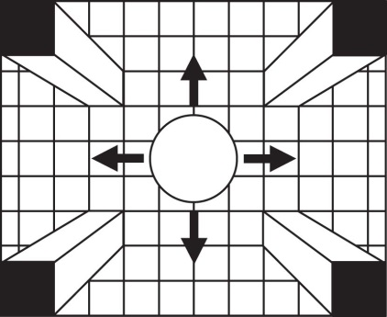

**Full Dome Mirror** **Four-Way Intersection**

Mirrored full domes are generally suspended in the middle of a 3 or 4-way intersection to provide a 180 degree view from any direction. The size of the dome can be determined by using a general suggestion of 1 inch of mirror diameter, providing about 1 foot of viewing distance. Domes should be suspended at least one foot above the tallest forklift mast or moving product load. The combination of the dome height and traffic speed might encourage using a larger mirrored dome for a wider viewing area, and increased warning time. ***All domes have an option of a yellow/black safety border to direct attention to the images shown in the mirror.***

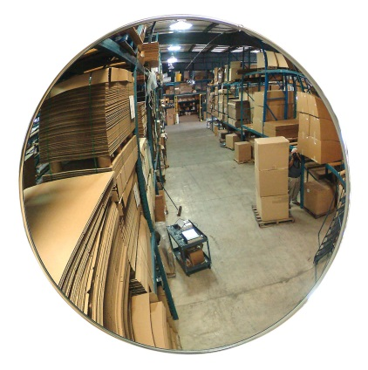 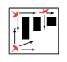

**Indoor Convex Mirror** **Convex Mirror View Angles**

Convex mirrors are positioned in a vertical position and provide a 130-150 degree viewing angle. Many of these mirrors are placed to expose aisles leading to 90 degree corners. The suggested size is the same as the dome mirrors, 1” of mirror diameter providing about 1 foot of viewing distance in each direction. (Mounting brackets included with each unit)

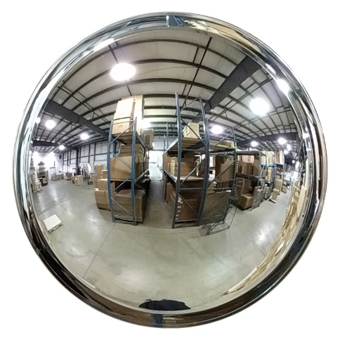 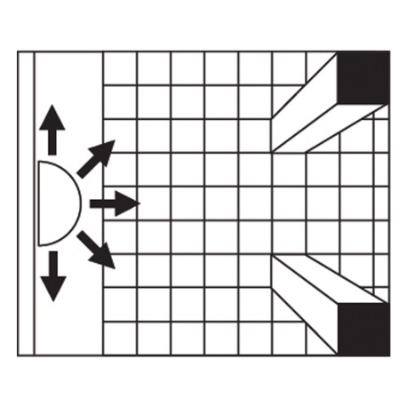

***DomeVex* Wide View Convex Mirror** ***DomeVex* Viewing Angles**

Se-Kure Domes and Mirrors has a unique solution to many problem intersections, the hybrid ***DomeVex*** line of wider view convex mirrors. These special mirrors provide three times the viewing area of a regular convex mirror. The ***DomeVex*** mirrors are made to provide a full 180 degree viewing exposure, with the clarity and vertical mounting flexibility of a regular convex mirror. A truly pro-active solution, bringing the 180 degree viewing surface down to the eye level of pedestrians and forklift operators.

Horns, cameras, blue light warning and motion detecting systems with lights are great warning devices to add to the safety of the work place. But Safety Mirrors will show what is coming around a corner and an approaching vehicle will be able to see ***you as well*.**

**Se-Kure Domes and Mirrors Inc.**

**www.domesandmirrors.com**

**Sturgis, Michigan**

