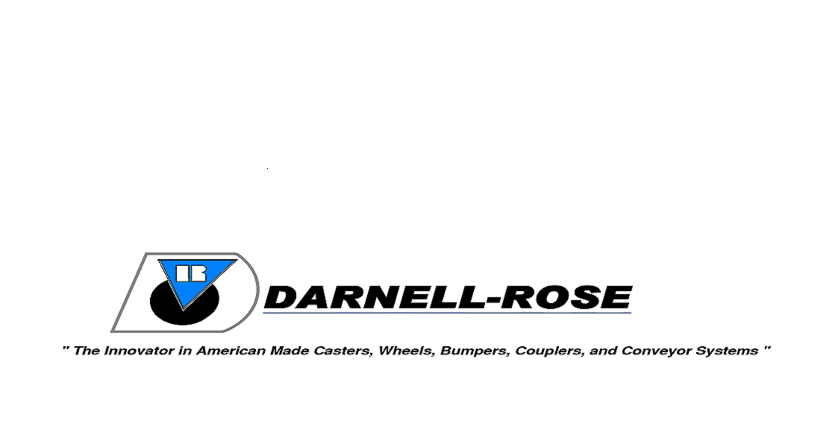

Proudly Introduces:

LevelMaster

LevelMaster is the latest product solution from Darnell-Rose, the innovator in high quality American made casters. This adjustable leveling caster is designed to move your heavy machinery or equipment into place, while also providing the capability of leveling and stabilizing to assure a sound foundation especially on uneven floor surfaces. Just mount it, roll it in place, and level it off to provide rock solid security for your most valuable assets.

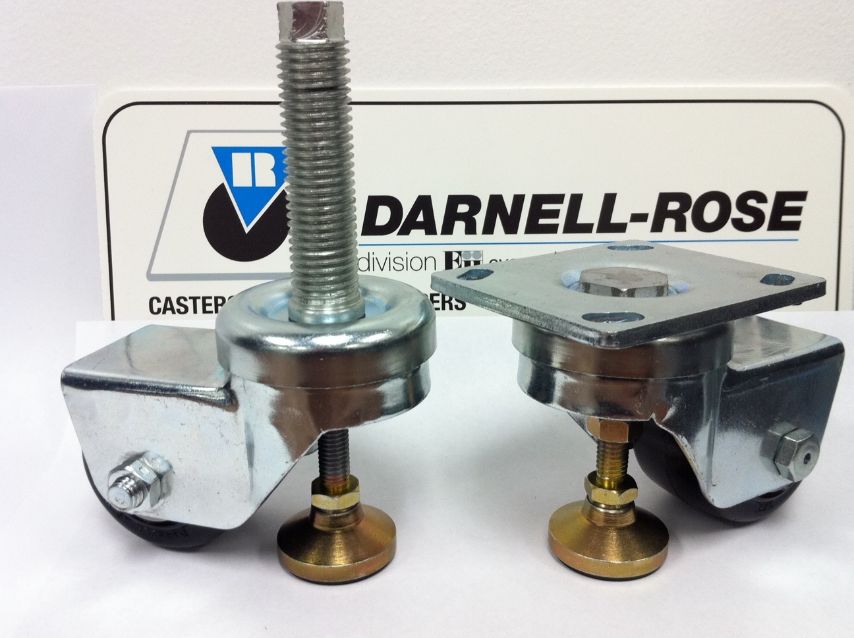
Modeled after our robust 83 Series swivel yoke, the Darnell-Rose LevelMaster is designed and engineered so that each caster can easily handle a maximum load up to 1000 lbs. Available in either plate or stem mounted options, the LevelMaster also features a shock absorbing non-slip rubber leveling pad for improved stability when engaged with floor surfaces.

World class quality, unmatched performance, and over 90 years of providing solutions for your mobility needs is the reason you should put your trust into Darnell-Rose casters, wheels, rubber bumpers, industrial truck couplers, and conveyor systems.

Proudly Introduces:

LevelMaster

Quality Features

• FOUR-SIDED, DOUBLE BALL RACEWAY.
Hardened steel ball bearings in the load bearing
and secondary thrust bearings touch the swivel
raceway “on all four sides.” This protects the extra
heavy duty 1” diameter central king pin from shock
loading for free swiveling under heavy loads.
• HEAT-TREATED MOVING PARTS.
All moving parts are heat treated to a precise
molecular depth and Rockwell hardness. This
extends caster life under rugged conditions and
shock loads.

Options

• Maintenance Free Swivel Bearings

• High-Temperature Wheels

• Conductive or Static-Dissipative Wheels

• Gray, Non-Marking Wheels

• Powder Coated Finishes

Wheel Diameter | Tread Width | Load Capacity | Wheel Material | Bearing | Swivel Part Number | Approx. Weight | Overall Height | Swivel Radius
3 | 1 13/16 | 500 | Polyolefin | Roller | 83-24-TPO-LM | 4 1/2 | 4 1/2 | 4 13/16
3 | 2 | 350 | Neoprene Rubber | Roller | 83-24-TDN-LM | 5 | 4 1/2 | 4 13/16
3 | 2 | 440 | Hi-Cap Neoprene | Roller | 83-24-TKN-LM | 5 | 4 1/2 | 4 13/16
3 | 2 | 800 | Hard Rubber | Roller | 83-24-TH-LM | 5 | 4 1/2 | 4 13/16
3 | 2 | 800 | Polyurethane / Cast Iron Hub | Roller | 83-24-TADI-M-CI-LM | 5 1/2 | 4 1/2 | 4 13/16
3 | 2 | 900 | Advanced Elastomer | Delrin | 83-24-DAE-LM | 5 | 4 1/2 | 4 13/16
 |  |  |  | Precision Ball | 83-24-PXAE-LM | 5 | 4 1/2 | 4 13/16
 |  |  |  | Roller | 83-24-TAE-LM | 5 | 4 1/2 | 4 13/16
3 | 2 | 1000 | Cast Iron | Roller | 83-24-TCI-LM | 5 1/2 | 4 1/2 | 4 13/16
3 | 2 | 1000 | Phenolic | Roller | 83-24-TPR-LM | 5 | 4 1/2 | 4 13/16

