 | EMH Crane Lifts Animal Care  at Zoo Atlanta

Features and Benefits  • Available in monorail and double-girder models, the EMH EG Series Hoist makes it easy to adjust trolleys to a variety of flange widths and beam types.  • The EMH Crane covers the entire facility with a span of 70 ft. and a runway length of 128 ft. A hoist hook height of 25 ft. was considered perfect for emergency elephant lifting.  • The EMH Crane was provided with NEMA 4 enclosures for water spray considerations, and a radio remote control allows zoo personnel to operate inside or outside the elephant enclosures.  Industry Groups:  • MHI Member Company  • Crane Manufacturers Association  of America (CMAA)  • Material Handling Equipment  Distributors Association (MHEDA)  According to Nate Elgart, Elephant Program Manager and Lead Elephant Keeper in Zoo Atlanta’s Animal Care Team,  “African elephants are tree-top grazers in their natural habitat, spending a lot of their time eating and grazing from the tops of trees. Using the crane system, we can hang food extremely high so that when they choose to eat, day or night, they must work a little for it, just like to do in the wild. Also, by using nets or barrels filled with all sorts of food, the crane system provides even more benefits to simulate a natural environment. Add to that, with remote push-button and radio crane control, we can move the food around, engaging the elephants to enjoy a better experience while providing them with a little exercise.” | 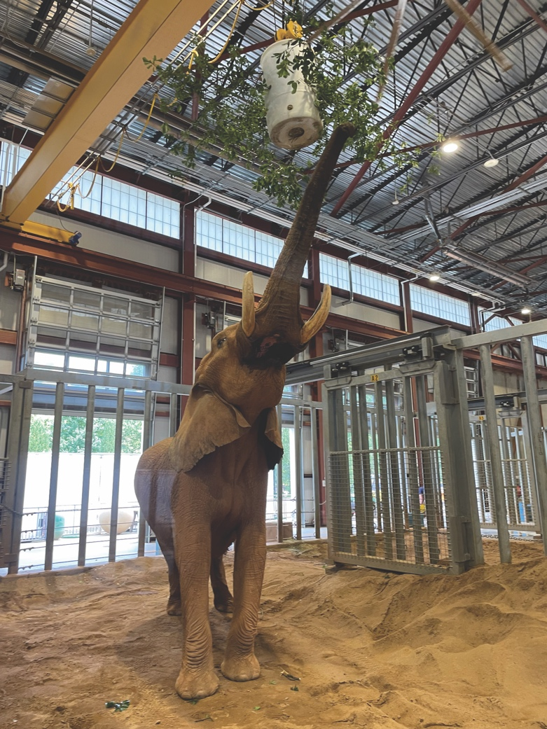  Since African Elephants are tree-top grazers in their natural habitat, the EMH Crane installation also provides an important side benefit.  Prior to the EMH Crane installation, when large animals such as an elephant needed emergency care, the Zoo had few options. One option was using a fixed hoist. Unfortunately, that only worked when the elephant was situated close to an exact spot under the hoist where the elephant could be easily accessed. The zoo augmented that option with add-ons, including harnesses, ropes, etc., all of which created a very complicated situation. In addition, like most zoos, Zoo Atlanta partnered with their local fire department, which used tripod lifting mechanisms. Fire Department partnerships still come into play when assisted lifts are required in outside areas.  During construction of the Zambezi Elephant Center, the decision was made to install an overhead EMH (Engineered Material Handling) 7.5-ton overhead crane system. Available in monorail and double-girder models, the EMH EG Series Hoist offers users a variety of features. For instance, the EG Hoist makes it easy to adjust trolleys to a variety of flange widths and beam types. A long adjustment tube maintains hoist integrity and tight staging during adjustment, and during opening and closing. A reliable hexagonal drive shaft enhances adjustment and reduces the number of parts involved. A limit switch (upper/lower) provides reliable repeatability during raising and lowering objects, and a weight-operated limit is provided as standard. EG Series Hoists are designed with spacious enclosures to accommodate large control panels and variable frequency drives. They are also available with capacities to handle 3, 5, 7.5 and 10 metric tons, and for 20, 33, 50 and 65-foot lifts.  The Crane covers the entire facility with a span of 70 ft. and a runway length of 128 ft. A hoist hook height of 25 ft. was considered perfect for emergency elephant lifting. The crane was provided with NEMA 4 enclosures for water spray considerations, and a radio remote control allows zoo personnel to operate inside or outside the elephant enclosures. A warning horn and flashing light when in operation were also included. The crane has been virtually maintenance free with only the yearly inspection required since it was made operational, and load tested in 2020. Speed considerations were paramount, so the bridge and trolley were furnished with variable speeds via VFD and 2-speed hoisting with 6:1 speed ratio for precision handling.  The new EG Series Hoist incorporates various safety features. A smooth acting rope guide tracks on a bar independent of the hoist frame to eliminate possible damage. The hoist also includes features that add to their ease of use. Along with a push-button control, the EMH EG Hoist includes the capability for remote-controlled operation. Many additional accessories can be added if desired.

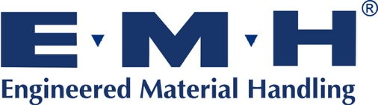 | Engineered Material Handling (EMH Crane)  550 Crane Drive, Valley City, OH 44280  Phone: 1-330-220-8600  Email: info@emhcranes.com  www.emhcranes.com

EMH Overhead & Workstation Cranes:

https://www.youtube.com/watch?v=HktvRVrdlgM

