November 7, 2011

Harrington Hoists, Inc. Selected for

“World’s Greatest!....” TV show

Manheim, PA – Harrington Hoists, Inc. is proud to announce that we have been chosen as a featured company on the “World’s Greatest!….” television show airing on the ION network.

“World’s Greatest!....” is a fast-paced tour around the world featuring behind-the-scenes footage and interviews of some of the most amazing and unique companies, products, people, and travel destinations the world has to offer. The half-hour shows reach households through independent cable networks and/or network affiliates.

Harrington Hoists, Inc. was selected above other similar manufacturers for our high standards of servicing our customers and for our innovative product line. Filming took place at our Manheim, PA location in early September. Harrington’s President and CEO, Ned Hunter, VP of Sales & Marketing, Carlo Lonardi and VP of Operations, Scott Miller each commented on what makes Harrington Hoists, Inc. a World’s Greatest company.

The segment is scheduled to air on the ION network:
- November 21 at 10:30am EST
- November 28 at 6:30am EST
- December 5, 2011 at 7:00am EST.

The ION channel listing for your viewing area and airing times for other time zones can be found in local TV Guides or cable and satellite provider web sites.

We hope you have the opportunity to view this program and see why Harrington Hoists, Inc. is considered the World’s Greatest!

For further details, please contact your local sales representative or our customer service department by calling Manheim, PA at 800-233-3010 and Corona, CA at 800-317-7111.

All of us at Harrington Hoists, Inc. would like to thank you for your continued support of our full range of hoist, crane and material handling products.
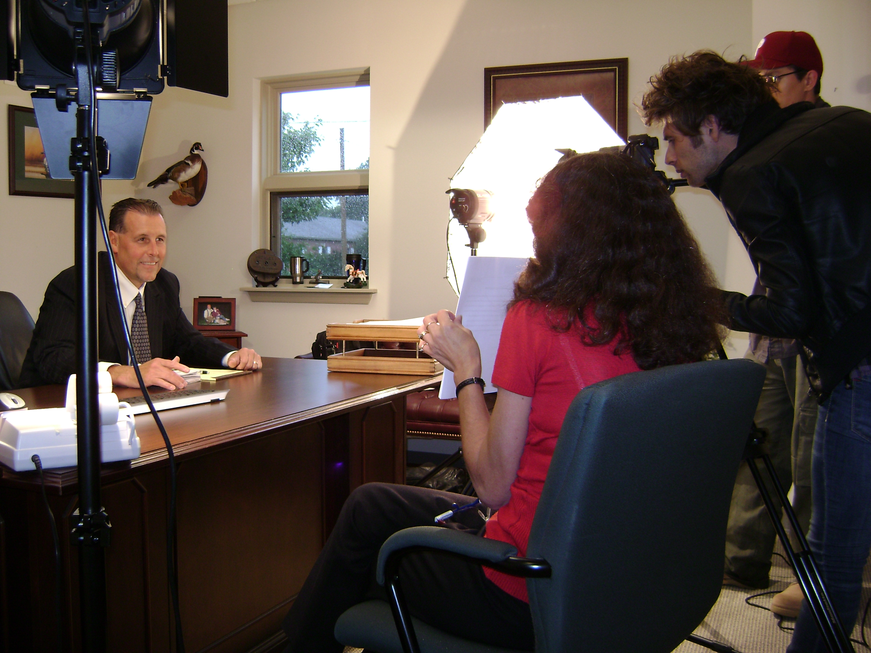

Best Regards,
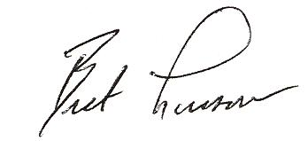
Bret Lussow
Business Development Sales Manager
Harrington Hoists, Inc.,401 West End Ave, Manheim, PA 17545
JOIN THE REVOLUTION

