Contact: Lyn Thorne  Marketing Manager  Phone: (708) 389-2100  Fax: (708) 389-0432 | 4100 W 124th Place  Alsip, IL 60803  www.kastalon.com | 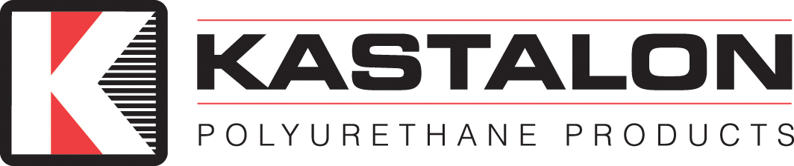

Press Release

Kastalon celebrates 50 years in business
March 13, 2013 marks 50 years for family owned business
Alsip, March 13, 2013: From a small borrowed space the size of a one car garage where material was mixed in coffee cans to 50,000 square feet of state of the art mixing and molding equipment, the DeMent family has continually reinvented itself as a world class custom polyurethane manufacturer.
The story began when a Southside Chicago man by the name of Robert DeMent heard about this new material called polyurethane that was the next best thing since sliced bread and was willing to risk everything he had to get his own business started. Like any new start-up, the first few years were tough. In lieu of paid employees, many times “Big Bob” brought parts home for his sons to finish.
Fast forward 50 years, after several moves and expansions, it is those two sons who now own the company and are strategically planning for the next 50 years. According to Bruce and Mike DeMent, co-owners, “the history, formation, size, and scope of Kastalon is based on the creativity, energy, and imagination of its employees who funnel their energies and expertise for the betterment of the product we supply our customers.”
Today, Kastalon, Inc. is in the business of designing, engineering, and manufacturing polyurethane components for a wide variety of applications and industries. These industries include steel and metals manufacturing, heavy equipment, military, aerospace, materials handling, industrial machinery, food, mining, appliances, building materials and any opportunity requiring high quality polyurethane parts.
This year is about celebrating the past, but more importantly, planning the future. For more information, visit www.kastalon.com.

