Play a role in shaping the department’s communication strategies for teens.

Share your ideas directly with the department of labor on how to provide work-related resources to teens, employers and other caring adults.

Help us ensure safe and fair workplaces for all teens.
JOIN THE DISCUSSION!
April 19 - April 30, 2021

The Empowering Teens in Their Workplaces Online Dialogue is designed to bring teens, parents, caring adults, and employers together in a conversation around promoting positive and safe work experiences for teens. Share your ideas on the best ways to engage and educate current and prospective teen workers about workplace rights, workplace hazards and exposure controls, and other related concerns for teens, including through social media.
WHO CAN PARTICIPATE

- Teens ages 14 – 19 who are employed or will become employed in temporary jobs year-round
- Parents, Family Members, and Any Caring Adults
- Teachers
- Youth Services Professionals
- Employers

HOW TO PARTICIPATE

Register at teenworkers.ideascale.com. From April 19 to April 30, share your ideas, and comment and vote on ideas submitted by others on how DOL can best provide teen workers, employers, and other influential adults with the resources they need to ensure the workplace is a safe and fair environment for teens, including teens with disabilities. 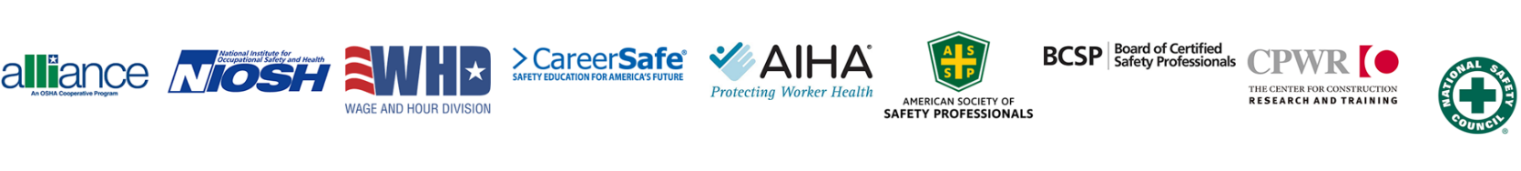
For additional information or questions, please contact Shaharazade Thompkins-Lewis, OSHA – Office of Outreach Services and Alliances, at Thompkins-Lewis.Shaharazade@dol.gov.

